**Introduction to Computers II – Assignment #7**

Please implement the following classes:

1. GeneralPlayer
   * data members
     + string name // Stores the name of the player
     + int hp // Stores the HP of the player, >= 0
     + int mp // Stores the MP of the player, >= 0
     + int exp // Stores the experience of the player, >= 0. Will not reset to zero after level-up
     + int level; // Stores the level of the player, >= 1
     + int attack; // stores attack of the player
     + int defense; // stores defense of the player
     + int max_hp; // stores max. HP of the player
     + int max_mp; // stores max. MP of the player
     + int lvup_exp; // stores needed exp. to level-up
   * public functions
     + GeneralPlayer(); // default constructor, with level = 1, name = “anonymous”
     + GeneralPlayer(int); // normal constructor, initializes level of the player, name = “anonymous”
     + GeneralPlayer(int, string); // normal constructor, initializes level and name of the player
     + GeneralPlayer(const GeneralPlayer&); //Copy constructor. Call setAttr() in setLevel() to set attributes
     + void setName(string);
     + string getName(void) const;
     + void setLevel(int); // need to call setAttr() inside
     + int getLevel(void) const;
     + int getHP()
     + void setHP(int)
     + int getMP()
     + void setMP(int)
     + int getExp()
     + void setExp(int)
     + void setAttr(int);
     + void levelUp(void);
     + void increaseHP(int);
     + void increaseMP(int);
     + void increaseExp(int);
     + void recoverHP(void); // hp = max_hp;
     + void recoverMP(void); // mp = max_mp;

2. OrcPlayer

* + - constructors
    - OrcPlayer();
    - OrcPlayer(int);
    - OrcPlayer(int, string);
    - OrcPlayer(const OrcPlayer&);
    - void setLevel(int);
    - void setAttr(int);
    - void levelUp(void);
    - other functions

3. KnightPlayer

* + - KnightPlayer();
    - KnightPlayer(int);
    - KnightPlayer(int, string);
    - KnightPlayer(const KnightPlayer&);
    - void setLevel(int);
    - void setAttr(int);
    - void levelUp(void);
    - void heal(void);
    - other functions

4. MagicianPlayer

* + - MagicianPlayer();
    - MagicianPlayer(int);
    - MagicianPlayer(int, string);
    - MagicianPlayer(const MagicianPlayer&);
    - void setLevel(int);
    - void setAttr(int);
    - void levelUp(void);
    - void pray(void);
    - other functions

Level-up Formulas

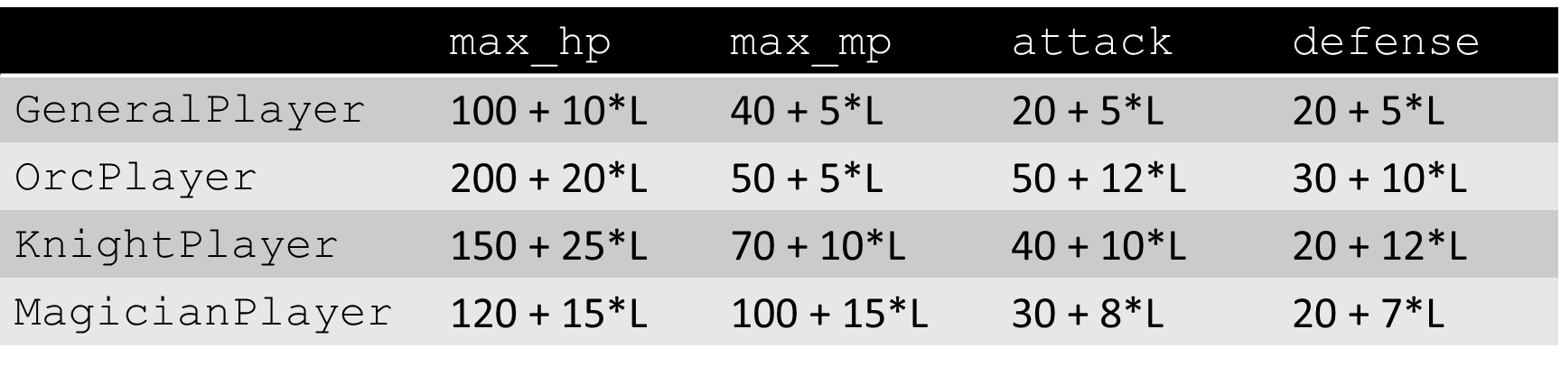

$$\text{lvup_exp}={ceiling(10}^{\log_{2}{(level+1)}})$$

e.g.

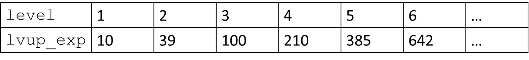

C:\Users\10310\Desktop\IC_HW\IC2_HW7>compile

C:\Users\10310\Desktop\IC_HW\IC2_HW7>g++ OrcPlayer.cpp GeneralPlayer.cpp main.cpp -o main.exe

C:\Users\10310\Desktop\IC_HW\IC2_HW7>pause

請按任意鍵繼續 . . .

C:\Users\10310\Desktop\IC_HW\IC2_HW7>main.exe

General Player:

Default Constructor:

Player: anonymous

Level: 1

HP: 110/110

MP: 45/45

Exp: 1

9 to go to level up

Att: 25

Def: 25

Copy Constructor:

Player: anonymous

Level: 1

HP: 110/110

MP: 45/45

Exp: 1

9 to go to level up

Att: 25

Def: 25

Level Constructor:

Player: anonymous

Level: 5

HP: 150/150

MP: 65/65

Exp: 210

175 to go to level up

Att: 45

Def: 45

Level-Name Constructor:

Player: G4

Level: 3

HP: 130/130

MP: 55/55

Exp: 39

61 to go to level up

Att: 35

Def: 35

HP decreased by 3:

Player: G4

Level: 3

HP: 127/130

MP: 55/55

Exp: 39

61 to go to level up

Att: 35

Def: 35

MP decreased by 4:

Player: G4

Level: 3

HP: 127/130

MP: 51/55

Exp: 39

61 to go to level up

Att: 35

Def: 35

Exp increased by 5:

Player: G4

Level: 3

HP: 127/130

MP: 51/55

Exp: 44

56 to go to level up

Att: 35

Def: 35

Exp increased by -5:

Error: the increment of Exp should be a positive integer.

Player: G4

Level: 3

HP: 127/130

MP: 51/55

Exp: 44

56 to go to level up

Att: 35

Def: 35

HP recovered:

Player: G4

Level: 3

HP: 130/130

MP: 51/55

Exp: 44

56 to go to level up

Att: 35

Def: 35

MP recovered:

Player: G4

Level: 3

HP: 130/130

MP: 55/55

Exp: 44

56 to go to level up

Att: 35

Def: 35

G4:

Name:New Name

Warning: HP has exceeded, HP is max.

HP:130

Warning: MP has exceeded, MP is max.

MP:55

Set Exp 1000:

Player: New Name

Level: 7

HP: 170/170

MP: 75/75

Exp: 1000

0 to go to level up

Att: 55

Def: 55

Set Level 10:

Player: New Name

Level: 10

HP: 200/200

MP: 90/90

Exp: 2099

782 to go to level up

Att: 70

Def: 70

Level Up:

Player: New Name

Level: 11

HP: 210/210

MP: 95/95

Exp: 2099

1747 to go to level up

Att: 75

Def: 75

Orc Player:

Default Constructor:

Player: anonymous

Level: 1

HP: 220/220

MP: 55/55

Exp: 1

9 to go to level up

Att: 62

Def: 40

Copy Constructor:

Player: anonymous

Level: 1

HP: 220/220

MP: 55/55

Exp: 1

9 to go to level up

Att: 62

Def: 40

Level Constructor:

Player: anonymous

Level: 5

HP: 300/300

MP: 75/75

Exp: 210

175 to go to level up

Att: 110

Def: 80

Level-Name Constructor:

Player: G4

Level: 3

HP: 260/260

MP: 65/65

Exp: 39

61 to go to level up

Att: 86

Def: 60

HP decreased by 3:

Player: G4

Level: 3

HP: 257/260

MP: 65/65

Exp: 39

61 to go to level up

Att: 86

Def: 60

MP decreased by 4:

Player: G4

Level: 3

HP: 257/260

MP: 61/65

Exp: 39

61 to go to level up

Att: 86

Def: 60

Exp increased by 5:

Player: G4

Level: 3

HP: 257/260

MP: 61/65

Exp: 44

56 to go to level up

Att: 86

Def: 60

Exp increased by -5:

Error: the increment of Exp should be a positive integer.

Player: G4

Level: 3

HP: 257/260

MP: 61/65

Exp: 44

56 to go to level up

Att: 86

Def: 60

HP recovered:

Player: G4

Level: 3

HP: 260/260

MP: 61/65

Exp: 44

56 to go to level up

Att: 86

Def: 60

MP recovered:

Player: G4

Level: 3

HP: 260/260

MP: 65/65

Exp: 44

56 to go to level up

Att: 86

Def: 60

G4:

Name:Player: New Name

Level: 3

HP: 260/260

MP: 65/65

Exp: 44

56 to go to level up

Att: 86

Def: 60

Warning: HP has exceeded, HP is max.

HP:Player: New Name

Level: 3

HP: 260/260

MP: 65/65

Exp: 44

56 to go to level up

Att: 86

Def: 60

Warning: MP has exceeded, MP is max.

MP:Player: New Name

Level: 3

HP: 260/260

MP: 65/65

Exp: 44

56 to go to level up

Att: 86

Def: 60

Set Exp 1000:

Player: New Name

Level: 7

HP: 340/340

MP: 85/85

Exp: 1000

0 to go to level up

Att: 134

Def: 100

Set Level 10:

Player: New Name

Level: 10

HP: 400/400

MP: 100/100

Exp: 2099

782 to go to level up

Att: 170

Def: 130

Level Up:

Player: New Name

Level: 11

HP: 420/420

MP: 105/105

Exp: 2099

1747 to go to level up

Att: 182

Def: 140

C:\Users\10310\Desktop\IC_HW\IC2_HW7>pause

請按任意鍵繼續 . . .